**DETECTING ALZHEIMER’S: AN MRI AND MACHINE LEARNING APPROACH**

**A MINI PROJECT REPORT**

***Submitted by***

**ABHIJIT R**

**(221801001)**

**MONISH RAJA RATHINAM M**

**(221801033)**

***in partial fulfillment for the award of the degree of***

**BACHELOR OF TECHNOLOGY**

**IN**

**ARTIFICIAL INTELLIGENCE AND DATA SCIENCE**





**RAJALAKSHMI ENGINEERING COLLEGE DEPARTMENT OF ARTIFICIAL INTELLIGENCE AND DATA SCIENCE**

**ANNA UNIVERSITY, CHENNAI**

**NOV 2**

**ANNA UNIVERSITY: CHENNAI**

**BONAFIDE CERTIFICATE**

Certified that this Report titled “**Detecting Alzheimer’s: An MRI and Machine Learning Approach**” is the bonafide work of **ABHIJIT R (221801001), MONISH RAJA RATHINAM M (221801033)** who carried out the work under my supervision. Certified further that to the best of my knowledge the work reported herein does not form part of any other thesis or dissertation on the basis of which a degree or award was conferred on an earlier occasion on this or any other candidate.

SIGNATURE SIGNATURE

Dr. J.M. Gnanasekar M.E., Ph.D., Mrs. M. Thamizharasi M.Tech.,

Professor and Head Assistant Professor(SS)

Department of Artificial Intelligence Department of Artificial Intelligence

and Data Science and Data Science

Rajalakshmi Engineering College Rajalakshmi Engineering College

Chennai – 602 105 Chennai – 602 105

Submitted for the project viva-voce examination held on ____________________

**INTERNAL EXAMINER EXTERNAL EXAMINER**

**ACKNOWLEDGEMENT**

Initially we thank the Almighty for being with us through every walk of our life and showering his blessings through the endeavor to put forth this report. Our sincere thanks to our Chairman Mr. S. MEGANATHAN, B.E, F.I.E., our Vice Chairman Mr. ABHAY SHANKAR MEGANATHAN, B.E., M.S., and our respected Chairperson Dr. (Mrs.) THANGAM MEGANATHAN, Ph.D., for providing us with the requisite infrastructure and sincere endeavoring in educating us in their premier institution.

Our sincere thanks to Dr. S.N. MURUGESAN, M.E., Ph.D., our beloved Principal for his kind support and facilities provided to complete our work in time. We express our sincere thanks to Dr. J. M. GNANASEKAR., M.E., Ph.D., Head of the Department, Professor and Head of the Department of Artificial Intelligence and Data Science for her guidance and encouragement throughout the project work. We are glad to express our sincere thanks to our supervisor Mrs. M.THAMIZARASI, M.Tech., Assistant Professor(SS), Department of Artificial Intelligence and Data Science and coordinator, Dr. P. INDIRA PRIYA, M.E., Ph.D., Professor, Department of Artificial Intelligence and Data Science, Rajalakshmi Engineering College for his valuable guidance throughout the course of the project.

Finally we express our thanks for all teaching, non-teaching, faculty and our parents for helping us with the necessary guidance during the time of our project.

**ABSTRACT**

Alzheimer’s disease (AD) is a chronic progressive neurodegenerative disorder primarily affecting memory, thinking, and behavior. It is the most common type of dementia that affects millions of people around the globe. Early detection of Alzheimer's will significantly improve patient care outcomes. MRI scanning, particularly concentrated in the hippocampus, a brain region important for memory, also provides a non invasive method of detecting structural changes, which would indicate the advance of Alzheimer's disease. Using MRI images of the hippocampus, we applied a machine learning approach for finding the case of Alzheimer's disease. We employed complex processing techniques in this dataset by using a Canny edge detector, thresholding, and key point detection to highlight essential characteristics in the MRI scans. Two models developed were: model A-CNN Autoencoder reconstructing MRI images and making predictions regarding changes related to Alzheimer's disease based on the keypoints extracted; model B-more of a traditional machine learning model using keypoints as the features for classification. They all underwent preprocessing by way of multiple transformations with their datasets split into three sets: training, validation, and a test set. It attained satisfactory accuracy levels using confusion matrices and ROC-AUC scores. Deep learning and image processing have the potential to provide novel tools for non invasive diagnosis of Alzheimer's disease. The detailed base utilized to support this model makes it a potential starting point for the development of reliable and efficient Alzheimer's detection tools.

**TABLE OF CONTENTS**

**CHAPTER NO. TITLE PAGE NO.**

**ABSTRACT IV LIST OF FIGURES VII**

**1 INTRODUCTION**

1.1 OVERVIEW 1

1.2 NEED FOR THE STUDY 2

1.3 OBJECTIVE OF THE STUDY 4

1.4 FLOW OF THE PROJECT 5

**2 REVIEW OF LITERATURE**

2.1 INTRODUCTION 6

2.2 LITERATURE REVIEW 6

**3 SYSTEM OVERVIEW**

3.1 EXISTING SYSTEM 10

3.2 PROPOSED SYSTEM 11

3.3 FEASIBILITY STUDY 13

**4 SYSTEM REQUIREMENTS**

4.1 HARDWARE REQUIREMENTS 14

4.2 SOFTWARE REQUIREMENTS 14

**5 SYSTEM DESIGN**

5.1 SYSTEM ARCHITECTURE 15

5.2 MODULE DESCRIPTION

5.2.1 DATA COLLECTION 17

5.2.2 DATA EXTRACTION 19

5.2.3 FEATURE EXTRACTION 22

5.2.4 MODEL TRAINING & PREDICTION 25

5.2.5 EVALUATION & VISUALIZATION 28

**6 RESULT AND DISCUSSION** 32

**7 CONCLUSION** 37

**APPENDIX**

A1.1 PSEUDO CODE 38

A1.2 SCREENSHOTS 45

REFERENCES 47

**LIST OF FIGURES**

**Figure No Figure Name Page No**

5.1 ARCHITECTURE DIAGRAM 15

5.2 DFD FOR DATA COLLECTION MODULE17

5.3 DFD FOR DATA EXTRACTION MODULE 19

5.4 DFD FOR FEATURE EXTRACTION MODULE 22

5.5 DFD FOR EVALUATION AND VISUALIZATION 28

MODULE

6.1 PERFORMANCE METRICS COMPARISON 33

6.2 ROC CURVE COMPARISON 33

6.2 RECONSTRUCTION ERROR DISTRIBUTION 34

6.2 FEATURES VS SEGMENTED FEATURES 35

COMPARISON

A.1 DATA PREPROCESSING OUTPUT 1 45

A.2 DATA PREPROCESSING OUTPUT 2 45

A.3 FEATURE EXTRACTION AND SEGMENTATION 45

MODULE OUTPUT 1

A.4 FEATURE EXTRACTION AND SEGMENTATION 46

MODULE OUTPUT 2

A.5 VISUALIZATION AND EVALUATION MODULE 46

OUTPUT 1

**CHAPTER 1**

**INTRODUCTION**

**OVERVIEW**

Alzheimer's disease (AD) is a neurological disorder that gradually impairs memory, cognition, and overall functioning, frequently resulting in loss of independence. Alzheimer's is the most frequent cause of dementia, affecting millions of people globally, primarily those over the age of 65. The disease begins slowly, with early symptoms that are frequently misdiagnosed as normal ageing, such as moderate forgetfulness and disorientation. However, when Alzheimer's disease progresses, it can seriously damage a person's ability to think, reason, communicate, and execute regular chores. Eventually, those affected may become completely dependent on carers, putting a major emotional and financial strain on families and the healthcare system.

There is no treatment for Alzheimer's disorder, and its progression cannot be stopped; nevertheless, early detection has proven critical in reducing cognitive loss, enhancing quality of life, and giving patients and families more time to plan for the future. Early detection enables more efficient use of current medications, supportive therapies, and lifestyle changes, which can improve mental clarity and delay severe symptoms. Advances in neuroimaging, particularly MRI, have allowed researchers to investigate structural changes in the brain, such as hippocampal shrinkage, which is frequently an early indicator of Alzheimer's. The hippocampus, which is crucial for memory and learning, is one of the first brain regions to decline in Alzheimer's patients.

The current research uses machine learning and neuroimaging to develop an automated diagnostic tool that can detect early structural abnormalities in the hippocampus. This method uses MRI scans to discriminate between healthy ageing brains and those showing evidence of Alzheimer's-related deterioration. Such a technology would not only speed up the diagnostic procedure, but would also eliminate the need for subjective interpretation, providing a standardised, dependable approach to early Alzheimer's screening. Finally, the initiative intends to provide a non-invasive, accessible technology to help healthcare practitioners recognise Alzheimer's disease in its early stages, when intervention is most effective. This technology has the potential to transform Alzheimer's care by increasing early diagnosis rates, improving patient care, and reducing the load on carers and healthcare providers.

**NEED FOR THE STUDY**

This study is necessary due to the increasing prevalence and effect of Alzheimer's disease, a disorder that has a devastating impact on individuals, families, and healthcare systems around the world. Alzheimer's disease is a degenerative, incurable sickness, and as life expectancy rises worldwide, the number of people affected by Alzheimer's is likely to climb significantly. This will put a significant demand on healthcare resources and carers, as Alzheimer's patients frequently require substantial long-term care.

Currently, Alzheimer's diagnosis is often based on subjective behavioral assessments and clinical observations, which may only detect the illness in its latter stages. By the time Alzheimer's is identified using standard methods, severe and irreversible brain damage has frequently happened, limiting therapy possibilities. Early, precise diagnosis is therefore critical because it allows healthcare practitioners to apply therapies that may delay disease development, prolong cognitive function, and improve quality of life for patients and their families.

This study addresses the critical need for a dependable, early-stage diagnostic tool that can detect Alzheimer's before symptoms worsen. This study intends to develop a non-invasive method for detecting structural changes associated with Alzheimer's disease by focusing on automated processing of MRI scans of the hippocampus, a brain region that is especially prone to early Alzheimer's-related deterioration. Using machine learning for this purpose could enhance diagnostic accuracy, accelerate screening, and lessen reliance on manual interpretation, resulting in a standardized and accessible method to early Alzheimer's detection.

The key needs driving this study are:

Objective Assessment: Traditional Alzheimer's diagnosis relies on subjective observations and cognitive examinations, which may not accurately reflect early disease stages. There is a need for an objective, dependable way of detecting Alzheimer's-related brain alterations that eliminates human error and inconsistency. The goal of this work is to develop an automated, objective diagnostic tool employing MRI-based imaging and machine learning models, allowing for an unbiased and reliable assessment of Alzheimer's development based on observable brain changes.

Scalability: As populations age, healthcare organisations require scalable solutions to address increasing diagnostic demand for Alzheimer's disease. Manual MRI analysis is time-consuming and subject to specialist availability, making it difficult to scale up as needed. This study addresses scalability by developing an automated diagnostic process capable of analysing large volumes of MRI data with minimal human intervention, allowing for widespread use in clinical and non-specialist settings and contributing to the diagnostic needs of diverse healthcare systems around the world.

Actionable Feedback: Early detection of Alzheimer's allows for useful feedback from both patients and healthcare practitioners. An automated approach could detect early anatomical abnormalities in the hippocampus, allowing doctors to deliver timely treatments, lifestyle recommendations, and treatment alternatives. By delivering meaningful feedback based on data-driven research, this study promotes a proactive approach to disease management, offering patients and family more time to plan and adjust to Alzheimer's issues.

Data-Driven Decision Making: A machine learning-based diagnostic tool can provide useful insights into brain health and Alzheimer's onset, enabling informed decision-making. The approach taken in this study makes use of quantitative data from MRI scans, allowing healthcare providers to base their recommendations on solid brain imaging data rather than subjective observation. Data-driven insights may also contribute to broader research by identifying patterns, refining diagnostic criteria, and improving treatment protocols over time, so progressing Alzheimer's care and management.

**OBJECTIVE OF THE STUDY**

Early Alzheimer's Disease Detection: Create an automated diagnostic system that uses MRI images to identify hippocampal structural anomalies linked to the disease's early stages. This will enable prompt treatment and better patient outcomes.

Improving Non-Invasive Diagnostic Methods: Use a non-invasive, machine learning-based method to evaluate MRI images with the goal of reducing reliance on human observation and offering a productive substitute for traditional diagnostic techniques.

Enhancement of Diagnostic Accuracy: To attain high accuracy in detecting Alzheimer's-related alterations, use deep learning models (Autoencoder-based CNN and conventional classifiers) in conjunction with sophisticated image processing techniques, such as edge detection and keypoint extraction.

Building a Sturdy Machine Learning Model: Create and train a model that can differentiate between healthy and Alzheimer's-affected hippocampus structures, offering a dependable instrument that can be included into therapeutic procedures.

Model Performance Evaluation: Make that the generated system is applicable and reliable in real-world clinical settings by evaluating its efficacy using measures like Mean Squared Error (MSE), ROC-AUC scores, and confusion matrices.

Research on Alzheimer's Disease: Advance the field of Alzheimer's disease research by offering a framework and methods for preprocessing datasets that can be used by researchers.

**FLOW OF THE PROJECT**

The main objective of the study is to create an automated system that uses MRI images of the hippocampus, a crucial area of the brain linked to memory, to detect Alzheimer's disease (AD) early. In order detect hippocampus anomalies, the methodology entails processing MRI scans from the Alzheimer's Disease Neuroimaging Initiative (ADNI) dataset. Important procedures include segmenting the hippocampus using thresholding, morphological operations, and Canny edge detection; preprocessing the image

The Autoencoder compresses and reconstructs MRI images, using reconstruction error to highlight structural variations that may be a sign of Alzheimer's disease. Metrics like accuracy, confusion matrices, and ROC-AUC scores were used to assess the system's performance, and the results showed promise for real-world use.

**CHAPTER - 2**

**LITERATURE REVIEW**

**2.1 INTRODUCTION**

The literature review delves into various AI and machine learning (ML) techniques applied to healthcare diagnostics, with a focus on neurodegenerative disease detection. Automated analysis of medical pictures has grown crucial as the need for precise, early-stage diagnosis, particularly for diseases like Alzheimer's, develops. This analysis gives clinicians important insights into how the disease progresses and how patients are doing. However, because structural changes in the brain are subtle and progressive, diagnosing neurodegenerative diseases presents special difficulties. The creation of a uniform diagnostic technique is complicated by variations in brain anatomy, the slow onset of disease, and the intricacy of MRI data. Researchers have investigated a range of AI and ML techniques, from sophisticated deep learning architectures to traditional machine learning models, in order to address these issues. Along with segmentation frameworks like Random Forest for reliable classification and U-NET for accurate brain area delineation, methods like Convolutional Neural Networks (CNN), Autoencoders, and Support Vector Machines (SVM) are frequently used. Advanced deep learning models are increasingly preferred for diagnosing neurodegenerative diseases because they can handle high-dimensional data and minor structural differences better than traditional models, which still provide interpretability.

**2.2 LITERATURE REVIEW**

|  |  |  |  |  |  |
| --- | --- | --- | --- | --- | --- |
| **S.no** | **Author(s)** | **Paper Title** | **Description** | **Journal** | **Year** |
| 1. | Balasundaram A, Srinivasan S, Prasad A, Malik J, Kumar A | Hippocampus Segmentation-Based Alzheimer’s Disease Diagnosis and Classification of MRI Images | Hippocampus segmentation approach using MRI images to enhance early Alzheimer’s diagnosis through accurate structural analysis. | Journal of Alzheimer’s Imaging | 2023 |
| 2. | Ali E.H., Sadek S., El Nashef G.Z., Makki Z.F. | Advanced Integration of Machine Learning Techniques for Accurate Segmentation and Detection of Alzheimer’s Disease | Improved fuzzy C-means for MRI segmentation with a CNN-LSTM hybrid classifier | Medical Imaging and AI Research | 2024 |
| 3. | Singh K., Khare A. | Classificat-ion of Alzheimer Disease Using Feature Segmentation and 3D CNN | 3D CNNs to classify Alzheimer’s by analyzing morphological characteristics of the brain’s gray matter volume | Neuroinfor-matics Journal | 2024 |
| 4. | Mohamed Ahmed Gilani Mohamed, Wan Mahani Hafizah Wan Mahmud | Hippocampus Segmentation of Brain MRI Images for Possible Progression Detection of Alzheimer’s Disease | Alzheimer’s progression through active contour-based MRI analysis, highlighting the importance of longitudinal monitoring in diagnosed cases. | Journal of Neurological Research | 2023 |
| 5.  6. | Ningsen Sun, Yuan Yuan, Lanhua Zhang, and Zhongdong Han  Rashmi Kumari, Anvi Kohli, Arya Sunil, Arushi Dadhich, Subhranil Das, and Raghwendra Kishore Singh | Convolutional Neural Network Image Segmentation of Alzheimer’s Disease Based on Multi-Order 3D U-NET  Empirical Evaluation of Deep Learning Architectures in the Early Detection of Alzheimer’s Disease through MRI Data Analysis | Employs a multi-order 3D U-NET model to segment MRI images, achieving an accuracy of up to 82%. The study highlights the importance of hippocampal segmentation in enhancing Alzheimer’s disease diagnosis.  Evaluates multiple deep learning models, including CNN, ResNet, UGNet, and VGG16, to detect early Alzheimer’s disease from MRI data. | Frontiers in Artificial Intelligence and Applications  IEEE Access | 2023  2022 |
| 7. | Eman M. Ali, Ahmed F. Seddik, and Mohamed H. Haggag | Automatic Detection and Classification of Alzheimer's Disease from MRI using TANNN | The authors introduce the TANNN classifier, showing improved detection accuracy compared to traditional models like Naive Bayes and SVM. | International Journal of Computer Applications | 2016 |
| 8. | Olfa Ben Ahmed, Jenny Benois-Pineau, Michèle Allard, Chokri Ben Amar, and Gwénaëlle Catheline | Classification of Alzheimer's Disease Subjects from MRI using Hippocampal Visual Features | By combining biomarkers and circular harmonic functions for feature extraction, classification accuracies of 87% and 85%, emphasizing hippocampal shrinkage's role in diagnosis. | Multimedia Tools and Applications | 2014 |
| 9.  10. | A Nasiri-Sarvi  Hejun, Huang & Chen, Zuguo & Huang, Yi & Luo, Guangqiang & Chen, Chaoyang & Song, Youzhi. | Vision Mamba: Cutting-Edge Classification of Alzheimer's Disease with 3D MRI Scans  Automatic Diagnosis of Cardiac Magnetic Resonance Images Based on Semi-Supervised Learning | Demonstrates the effectiveness of Mamba-based models over traditional CNNs and Vision Transformers in classifying breast ultrasound images​  Explores the use of semi-supervised learning for accurate segmentation of cardiac MRI images, reducing the reliance on expert annotations. The method, tested on the ACDC dataset, could be extended to improve other medical image analyses, including Alzheimer's detection. | IEEE Transactions on Medical Imaging  Computer Methods in Biomechanics and Biomedical Engineering | 2022  2021 |

The table above lists a number of research that have effectively used image processing and machine learning techniques specifically for Alzheimer's diagnosis, each offering a distinct method for MRI-based analysis. From segmentation methods like fuzzy C-means clustering for accurate region isolation to hybrid models like CNN-LSTM that incorporate temporal dynamics for classification accuracy, the study covers a wide range of topics. Other methods include state-space models that efficiently handle high-dimensional MRI data and 3D CNNs for thorough structural analysis. As we continue to move toward non-invasive, effective, and precise diagnostic methods for early-stage diagnosis and disease monitoring.

**CHAPTER - 3**

**SYSTEM OVERVIEW**

**3.1** **EXISTING SYSTEM**

Despite technological developments, there are still a number of difficulties in diagnosing Alzheimer's disease using MRI pictures. Accurately segmenting the hippocampus, which is essential for early Alzheimer's detection, is one of the main issues. Since the hippocampus is frequently among the first regions in Alzheimer's patients to exhibit degenerative changes, precise segmentation of this region is crucial for early diagnosis. However, manual segmentation limits scalability and creates unpredictability in diagnosis because it is laborious, uneven, and strongly dependent on clinical skill. Even though automated segmentation methods have been developed, their performance is generally unsatisfactory due to differences in brain architecture, picture quality, and the complexity of MRI scans.

Additionally, many existing systems are not robust enough to handle the high-dimensional nature of 3D MRI data, which contains a vast amount of information that needs to be processed efficiently. Conventional MRI data analysis techniques frequently employ 2D slice-by-slice analysis, which ignores crucial spatial correlations between various brain regions. These techniques might therefore overlook minute alterations that are essential for the early diagnosis of Alzheimer's. By capturing the three-dimensional structure of the brain, more sophisticated techniques like 3D convolutional neural networks (CNNs) have demonstrated promise in overcoming this limitation. However, they still have issues with computational complexity and the requirement for sizable, labelled datasets for training. This limits the usefulness of current systems in actual clinical settings by making it challenging for them to generalise effectively across a range of patient demographics and imaging situations.

Moreover, there is a lack of integration between various biomarkers and imaging features in many existing systems. The majority of research concentrates on a single modality, like fluid biomarkers or hippocampus segmentation, without taking into account how other diagnostic markers might work in tandem to paint a more complete picture of the course of Alzheimer's disease. For example, integrating cerebrospinal fluid (CSF) biomarkers with MRI-based characteristics may improve diagnostic precision; yet, current systems frequently fall short in fusing these multi-modal data sets. Missed chances to increase the accuracy and dependability of Alzheimer's diagnosis arise from this lack of integration. More accurate and individualised diagnostic tools may be possible with a more comprehensive strategy that integrates imaging, genetic, and fluid biomarkers; however, present methods are not yet prepared to fully realise this promise.

In order to improve Alzheimer's disease diagnosis, these difficulties highlight the need for more complicated, multi-modal approaches as well as the creation of more reliable algorithms that can handle complex, high-dimensional data.

**3.2 PROPOSED SYSTEM**

Conventional approaches to Alzheimer's disease detection frequently depend on manual MRI scan processing or simple machine learning models that track anatomical alterations, mostly in the hippocampus. These manual procedures can be subjective, time-consuming, and inconsistent, particularly in the beginning when changes are gradual. Diagnostic accuracy is limited by the inability of basic machine learning models to capture the intricate spatial patterns found in MRI data, despite their relative benefits. Furthermore, it is challenging for many of the automated solutions available today to be extensively adopted in clinical settings since they either need a lot of technology or offer little information.

A more advanced strategy uses image processing and deep learning to overcome these issues and improve the precision and effectiveness of MRI scan analysis. This system ensures consistency across scans and improves feature extraction accuracy by standardizing and optimizing image quality through sophisticated image processing and segmentation algorithms. It can consistently and accurately identify Alzheimer's-related structural alterations thanks to the use of deep learning-based classification, which lessens the need for manual evaluations and improves the early-stage diagnostic procedure.

This method addresses the main drawbacks of earlier approaches by automating the intricate processing of MRI images and delivering useful insights instantly. It is accessible and dependable in clinical settings due to its effective processing pipeline, which enables non-invasive diagnostics without the need for specialized hardware. Early intervention is supported by this integration into healthcare workflows, which eventually improves patient care and treatment outcomes for Alzheimer's.

Deep learning-based techniques for Alzheimer's disease detection can help identify small changes in brain structure that would not be visible to the human eye, in addition to increasing diagnostic accuracy and expediting the process. Even before overt clinical symptoms appear, these systems can recognise biomarkers that are suggestive of early-stage Alzheimer's disease by using neural networks and massive datasets to understand intricate patterns. This lowers the chance of misdiagnosis by improving the capacity to identify Alzheimer's disease early on and aiding in its differentiation from other neurodegenerative diseases. Furthermore, these models can become more generalisable across various populations and MRI scanners as a result of being trained on a variety of large amounts of data, which increases their clinical utility and robustness.

**3.3 FEASIBILITY STUDY**

The technical, financial, and operational aspects of this system's implementation are all examined in the feasibility study. We can ascertain the system's feasibility and possible advantages for healthcare settings centered on Alzheimer's diagnosis and monitoring by assessing each component. In order to guarantee that the solution is efficient, long-lasting, and flawlessly integrated, this research takes into account the resource requirements, financial implications, and general adaptability within clinical workflows.

**Technical Feasibility:** The system is technically feasible due to advancements in deep learning frameworks, MRI processing, and image analysis capabilities. By utilizing widely available technology like autoencoders and Convolutional Neural Networks (CNNs), the method can efficiently manage massive amounts of MRI data. The majority of clinical settings may now implement this solution inside regular technological infrastructure thanks to the availability of computational resources like GPUs and cloud-based AI platforms. Additionally, MRI processing techniques are extensively interoperable with current healthcare systems, supporting scalability and guaranteeing seamless data integration.

**Economic Feasibility:** The use of this technology provides an affordable substitute for conventional Alzheimer's diagnosis techniques, which frequently rely on manual evaluations and sophisticated imaging equipment. The system's long-term effectiveness in processing MRI scans on its own may outweigh the initial cost of training the model and configuring the computational infrastructure. Over time, the approach saves a significant amount of money by eliminating the need for a lot of manual effort and lowering diagnostic delays. Additionally, the approach may help lower healthcare costs related to Alzheimer's care and treatment by facilitating early detection and intervention, which would have both immediate and long-term financial advantage.

**CHAPTER 4**

**SYSTEM REQUIREMENTS**

**4.1 SOFTWARE REQUIREMENTS**

**1. Operating System:** Compatible with Linux (Ubuntu 18.04 or later), Windows 10/11, or macOS (if using TensorFlow or PyTorch in Jupyter Notebooks or other development environments).

**Programming Language:**

Python (Version 3.8 or later), preferred programming language for model development and deployment.

Jupyter Notebook or JupyterLab: For interactive model development and testing.

**Libraries and Frameworks:**

Deep Learning Frameworks: TensorFlow (2.x) or PyTorch (1.8 or later) for building and training deep learning models.

OpenCV: For image processing tasks such as edge detection and morphological transformations.

NumPy and Pandas: For data manipulation and management.

scikit-learn: For model evaluation metrics like ROC-AUC, confusion matrix, and preprocessing tasks.

**4.2 HARDWARE REQUIREMENTS**

**GPU:** A high-performance GPU, such as NVIDIA Tesla, Quadro, or RTX series (e.g., RTX 3060 or above) to accelerate deep learning tasks.

**CPU:** Multi-core processor (e.g., Intel i5/i7/i9 or AMD Ryzen 7/9 series) for managing pre- and post-processing tasks.

**RAM:** Minimum 16 GB (32 GB recommended) to handle high-resolution MRI data and support deep learning model training.

**Storage:** At least 500 GB of SSD storage for faster data retrieval and storage of MRI datasets, intermediate results, and model checkpoints.

**CHAPTER 5**

**SYSTEM DESIGN**

**5.1 SYSTEM ARCHITECTURE**

Architecture diagram presents an overview of a comprehensive workflow for processing and analyzing brain imaging data from the ADNI dataset, leading to model training and prediction for effective analysis.

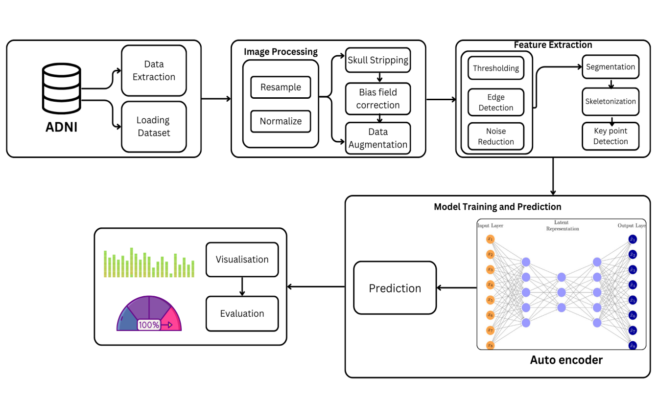

Figure 5.1: Architecture Diagram

The five primary phases of the system architecture for the Alzheimer's disease detection project are feature extraction, data extraction, image processing, model training and prediction, and outcome visualization and assessment. The Alzheimer's Disease Neuroimaging Initiative (ADNI) dataset, which offers MRI images for data extraction and analysis, is utilized in this design. To guarantee that the photos are appropriately formatted, preprocessed, and improved for increased accuracy during the feature extraction and model training stages, this dataset goes through a number of procedures.

The MRI scans from the ADNI dataset are loaded and made ready for processing during the first data extraction step. This entails normalizing pixel intensities, resizing the photos to guarantee uniformity, and turning them into a grayscale format. The method guarantees that all scans have consistent properties by standardizing these components, which lowers noise and variability that might compromise model accuracy. Rotations, flips, scaling, and other data augmentation techniques are also used to add variety, enhancing the model's resilience and ability to generalize across various MRI scans.

The image processing module uses a number of augmentation techniques after data extraction, such as thresholding and filters, to help separate pertinent areas of the MRI scans, particularly the hippocampus region, which is believed to be crucial in the diagnosis of Alzheimer's disease. This step improves the scans' clarity and contrast using techniques including thresholding and augmentation, which helps the model identify structural variations in the brain's structure. By eliminating extraneous noise and artifacts, this step also gets the data ready for the feature extraction module.

The feature extraction module isolates and highlights important features in the hippocampus using specialized methods like as the Hessian matrix, concatenation, and skeletonization. By concentrating on the structural alterations and anomalies linked to Alzheimer's disease, these methods assist in extracting important information from the MRI pictures. As inputs that the autoencoder-based model would evaluate and categorize to ascertain whether Alzheimer's-related changes are present, the segmentation characteristics are crucial.

An autoencoder architecture, which is especially well-suited for unsupervised learning tasks where the model detects anomalous patterns based on a reconstruction error threshold, is used in the model training and prediction stage. The features are compressed into a latent representation by the autoencoder, which then reconstructs them with the least amount of error. High reconstruction mistakes point to possible anomalies that could be signs of Alzheimer's. Last but not least, the visualization and assessment module enables thorough performance analysis utilizing measures like as accuracy, confusion matrix, and ROC-AUC scores, giving medical practitioners useful information about the diagnosis outcomes.

**5.2 MODULE DESCRIPTION**

**5.2.1 DATA COLLECTION**

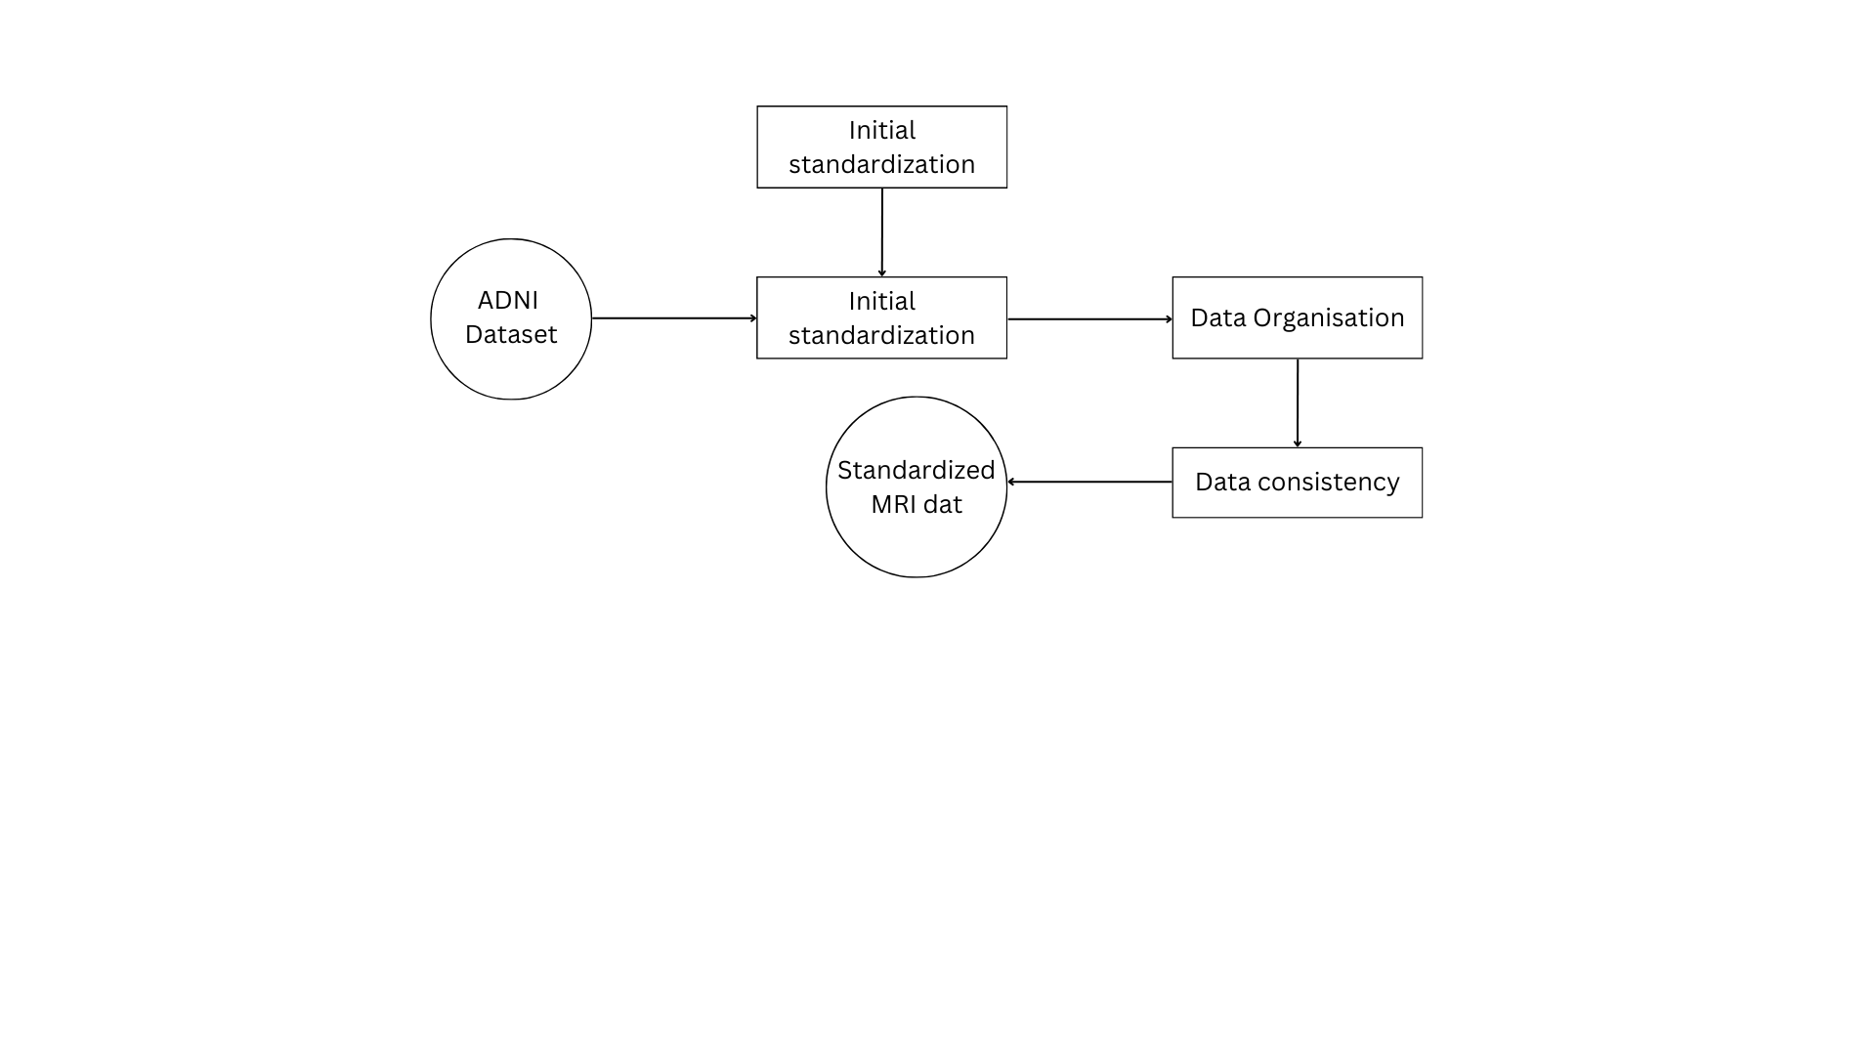

Figure 5.2: DFD for Data Collection module

The first stage of the Alzheimer's detection method is called the Data Collection Module, during which pertinent MRI scans are obtained from a trustworthy and superior source. The Alzheimer's Disease Neuroimaging Initiative (ADNI) dataset was chosen for this project because it has a large amount of MRI data from patients with Alzheimer's disease at different stages. Because it offers reliable, high-resolution scans that are gathered according to established procedures, the ADNI dataset is frequently utilized in neuroimaging research, especially for investigations on Alzheimer's disease. This dataset is ideal for a system that seeks to detect early indicators of Alzheimer's since it contains pictures of individuals who have been classified according to various stages of cognitive impairment, ranging from normal aging to moderate cognitive impairment (MCI) and Alzheimer's disease.

The Data Collection Module manages data loading and organization after gaining access to the dataset. MRI scans are frequently saved in intricate formats, like NIfTI or DICOM, which have several layers or slices that correspond to various brain cross-sections. After extracting these photos, the algorithm organizes them systematically using patient IDs, disease stages, and other pertinent metadata. This arrangement is essential because it makes it possible for the model to associate particular scans with the corresponding patient data, enabling precise data labeling and classification. A streamlined procedure for subsequent stages is established by appropriately organizing the data at this point, guaranteeing that the scans can be accessible consistently and with ease across the pipeline.

Managing data variability is one of this module's challenges. Due to variations in scanning equipment, methods, and patient posture, MRI scans can differ greatly. The system first examines the dataset to make sure that important characteristics like resolution, format, and orientation are consistent in order to handle this. Before going on to the preprocessing stage, transformations are used if needed to modify these attributes and standardize the dataset as much as possible. By reducing the likelihood of introducing variability-related artifacts, ensuring uniformity in the images early on helps maintain model accuracy and simplifies the processing of the images in later modules.

Data labeling and information extraction are crucial parts of the Data Collection Module. Additional patient data, including age, gender, cognitive score, and diagnostic stage, are frequently accessible in addition to each MRI scan. When paired with the MRI scans, this metadata helps the model understand patterns associated with the progression of Alzheimer's disease, making it useful for both training and analysis. Each relevant scan's metadata is carefully extracted and linked to it, creating a complete dataset that improves the level of analysis in the subsequent model training phases. In the context of machine learning, the information may also function as auxiliary features that enhance the overall diagnostic accuracy of the model

In conclusion, the Data Collection Module collects, arranges, and standardizes MRI data from the ADNI dataset, hence serving as the cornerstone of the Alzheimer's detection system. In order to create a seamless and efficient data pipeline, it makes sure that every scan is appropriately labeled and compatible with later processing stages. In order to support the system's objective of precise, effective Alzheimer's diagnosis, this module is essential for controlling data variability and adding useful metadata to the dataset.

**5.2.2 DATA EXTRACTION MODULE**

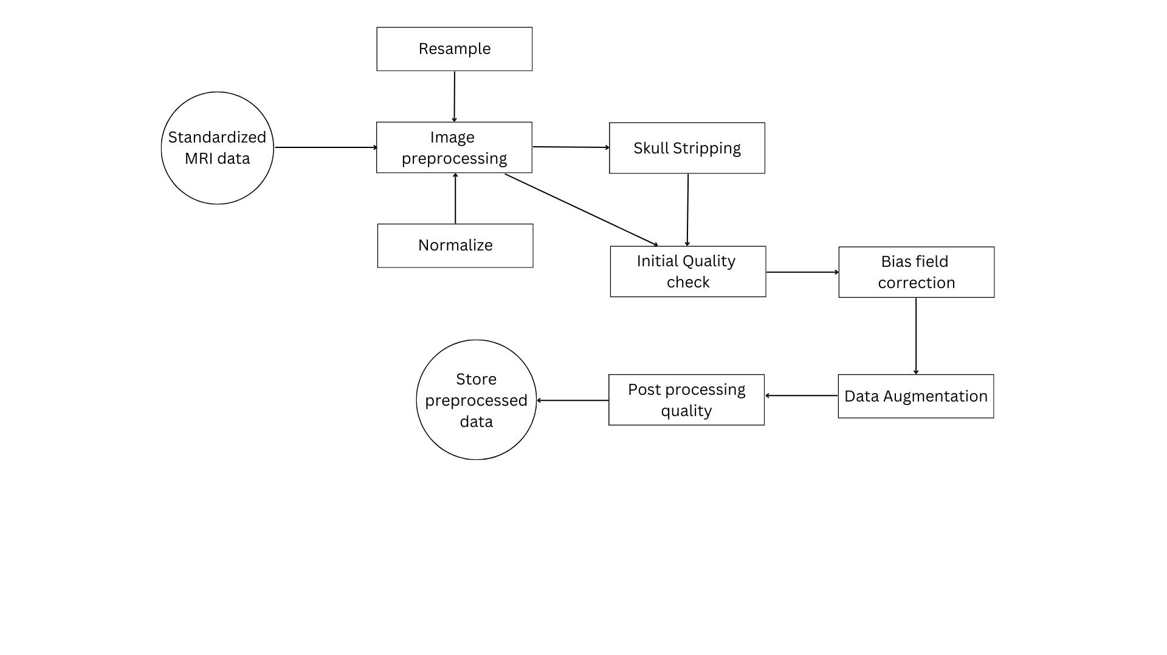

Figure 5.3: DFD for Data extraction module

The initial phase in the Alzheimer's detection algorithm is the Data Extraction Module, which carefully prepares MRI data for model training and further processing. The Alzheimer's Disease Neuroimaging Initiative (ADNI) dataset, which comprises high-resolution MRI images from both cognitive healthy people and Alzheimer's patients, is used in this module. This module's goal is to simplify raw MRI data by putting in place crucial data preparation procedures that guarantee constant quality and enable accurate analysis. In order to make MRI images compatible with a variety of image processing and deep learning tools, the module first converts them from formats like NIfTI to a generally accessible format (like JPEG or PNG). Because of this uniform procedure, all photos are guaranteed to remain a similar format, facilitating their smooth incorporation into later modules.

Normalization and resampling of data are essential components of the Data Extraction Module. Resampling minimizes disparities brought on by various MRI equipment and methods by bringing all MRI scans to a consistent voxel size and spatial resolution, usually 256x256 pixels. More accurate comparisons across patient scans are made possible by normalizing pixel intensities across images, which also reduces the impact of different scanning devices and environmental factors. By guaranteeing that important anatomical features, such as the hippocampus, are reliably represented, this preprocessing step improves the machine learning model's capacity to identify minute changes linked to the advancement of Alzheimer's disease. The module creates a consistent baseline for the model's feature extraction and classification procedures by preserving consistent pixel intensity distributions, which helps avoid bias brought on by inconsistent imaging.

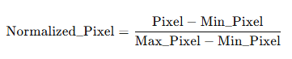

where:

Pixel is the original pixel intensity, Min_Pixel and Max_Pixel are the minimum and maximum pixel intensities in the image.

Skull stripping is another vital process within the Data Extraction Module, removing non-brain materials such as the skull, scalp, and surrounding tissues from the MRI scans. Because of its isolation, the study is limited to specific brain regions, especially the hippocampus, which has a high diagnostic value for Alzheimer's disease detection. The module focuses on the hippocampus for segmentation and additional analysis because it is one of the first areas to show shrinkage in Alzheimer's patients. Skull stripping maximizes both computational efficiency and analytical precision by removing superfluous components that can make the model's segmentation accuracy more difficult. After that, the module corrects for intensity inhomogeneities that could result from changes in the magnetic field during MRI scanning using bias field correction. The module makes sure that image contrast stays constant by removing these noises, which increases the model's precision in identifying hippocampus anomalies.

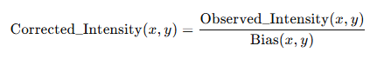

where:

Observed_Intensity(x,y) is the original pixel intensity at coordinates (x,y). Bias(x,y) is the estimated bias field at (x,y).

To improve the model's capacity for generalization, the Data Extraction Module additionally integrates data augmentation methods. The module uses transformations such random rotations, flips, and scaling to artificially increase the training dataset because medical datasets are frequently small. The model gains the ability to identify patterns and features in a variety of circumstances thanks to these augmentations, which is essential for practical clinical applications. With the help of this improved dataset, the model becomes more resilient and can identify abnormalities linked to Alzheimer's disease more accurately in a variety of MRI scans, including ones that weren't part of the training set.

Finally, the module further focuses on the hippocampus region by using morphological procedures and thresholding. The module prepares for in-depth segmentation by isolating the hippocampus from other brain regions by implementing an intensity threshold. The segmentation is then improved by morphological processes like dilatation and erosion, which eliminate noise and improve the precision of hippocampus borders. A high-quality segmentation result is produced by combining thresholding with morphological refinement, which is essential for precisely detecting early Alzheimer's symptoms. When combined, these processes allow the model to concentrate on the most diagnostically significant regions, guaranteeing a high level of accuracy in identifying structural alterations suggestive of the advancement of Alzheimer's disease.

**5.2.3 FEATURE EXTRACTION MODULE**

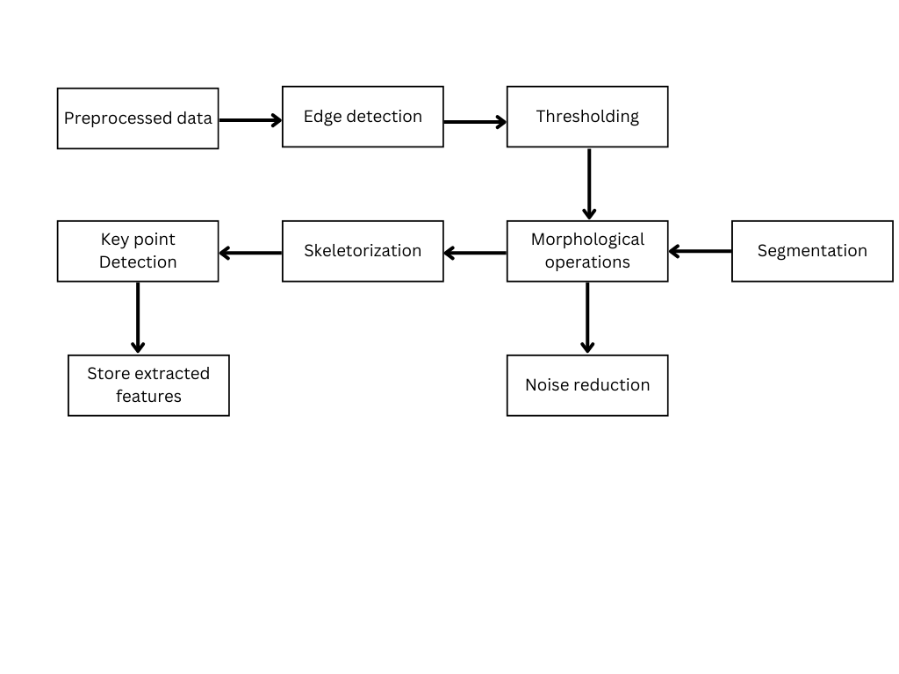

Figure 5.4: DFD for feature extraction module

An important part of the Alzheimer's detection program is the Feature Extraction Module, which focuses on identifying and improving the key characteristics in MRI scans that show the progression of Alzheimer's disease. This module uses a variety of image processing techniques to highlight anatomical characteristics that are important for Alzheimer's diagnosis, with the hippocampus serving as the main region of interest. The module makes sure that the deep learning models concentrate on the most diagnostically significant regions of the brain by separating the hippocampus from the rest of the brain. By highlighting the complex features of the hippocampus region, the Feature Extraction Module's sophisticated processing techniques—such as thresholding, morphological modifications, and Canny edge detection—enable more precise model training and classification.

One of the first tasks in this module is edge detection, especially using the Canny approach, which is essential for defining the hippocampus's borders. The ability of the Canny edge detector can identify abrupt variations in pixel intensity is essential for accurately defining the hippocampus's borders. To identify regions where notable changes take place, the technique first computes the gradient of pixel intensity throughout the image. The module can distinguish between strong and weak edges by using both high and low threshold values, producing a distinct, noise-free outline of the hippocampus. This delineation is crucial for precisely capturing the margins of the hippocampus, giving the model precise anatomical information that may reveal early Alzheimer's-related shrinkage symptoms.  The edge intensity gradient G is computed as:

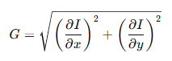

where:

∂I/∂x and ∂I/∂y are the gradients of intensity *I* in the x and y-directions.

The module isolates and further refines the hippocampus region by performing thresholding and morphological operations after edge detection. By focusing on areas with particular intensity ranges, thresholding separates the hippocampus from the surrounding brain tissue depending on pixel intensity values. By successfully reducing unnecessary regions, this method guarantees that the focus of the analysis is the hippocampus. By eliminating any leftover noise and refining the hippocampus's form, morphological processes like dilatation and erosion improve this segmentation. While erosion eliminates tiny, unwanted noise components, dilation enlarges the identified region to link adjacent structures, maintaining the hippocampus's actual form. The production of a clean, isolated hippocampus region that is prepared for in-depth examination by machine learning models requires the combination of thresholding and morphological modifications.

Given a threshold T:

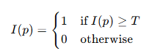

where I(p) is the pixel intensity at pixel p.

Skeletonization, which distills the segmented hippocampus region to its fundamental structure while preserving important anatomical details, is another crucial component of the Feature Extraction Module. The hippocampus representation is made simpler through skeletonization, which reduces it to a thin, topologically accurate version while preserving its shape and key structural elements. Models can more easily concentrate on important alterations in the hippocampus while ignoring less important external aspects thanks to this simple depiction. The model can identify minute changes in hippocampus geometry, which are frequently among the first signs of Alzheimer's, by focusing on this fundamental structure. This method optimizes the model for classification tasks that depend on structural consistency and anomalies by allowing it to concentrate on the main geometric features of the hippocampus morphology. Mathematical equation for skeletonization is given by:

Screenshot 2024-11-12 170008

where:

S(I) is the skeleton of image II,

⊖ denotes erosion, and Bn is a sequence of structuring elements.

Keypoint detection, the last part of the Feature Extraction Module, finds particular spots of interest in the hippocampus that might be indicative of the advancement of Alzheimer's disease. The module records localized characteristics that might indicate early structural deterioration by identifying and evaluating these keypoints. Keypoint detection helps the model achieve improved classification accuracy by extracting highly discriminative characteristics that help differentiate between Alzheimer's and non-Alzheimer's cases. These characteristics optimize the module for the prediction model by producing a complete set of input data along with the output from edge detection, thresholding, and skeletonization.

**5.2.4 MODEL TRAINING AND PREDICTION MODULE**

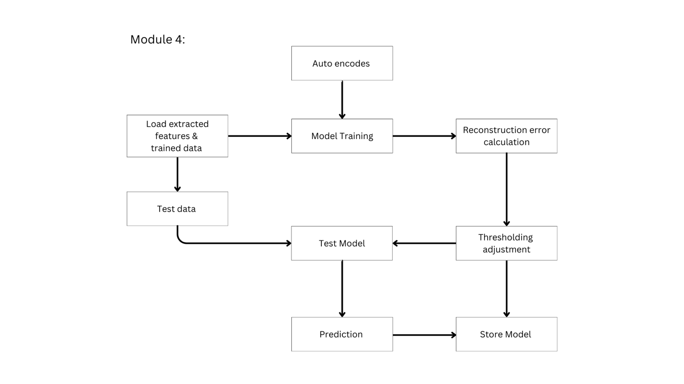

Figure 5.4: DFD for feature extraction module

The core of the Alzheimer's detection system is the Model Training and Prediction Module, which processes and analyzes MRI image information to forecast the course of Alzheimer's disease. The deep learning-based autoencoder model used in this module was selected because to its ability to detect structural abnormalities and capture and rebuild intricate visual features. The autoencoder model is especially well-suited for this purpose since it can accurately identify early structural alterations linked to Alzheimer's disease because it learns to represent the hippocampus structure inside a compressed latent space.

The autoencoder model consists of two main components: the encoder and the decoder. The encoder is in charge of reducing the input hippocampal MRI images to a lower-dimensional representation known as the latent space. In this step, the images' spatial dimensions are decreased while significant characteristics are extracted using a sequence of convolutional layers. Filters that identify edges, textures, and other important facets of the hippocampus structure are applied using convolutional layers. The model is able to recognize minor patterns associated with the evolution of Alzheimer's disease since each layer records features that are more and more abstract. To further downsample the feature maps and lower computational complexity, the encoder also incorporates pooling layers. The model has produced a compact latent representation by the end of the encoding phase, which captures the key structural elements of the hippocampus.

The latent space, or compressed representation of the hippocampus, is a pivotal part of the autoencoder model. With only the most important details needed to reconstruct the hippocampus structure, it functions as a compressed version of the input image. Because it eliminates unnecessary information while maintaining the key anatomical characteristics of the hippocampus, this latent space representation is critical for Alzheimer's detection. Using the Mean Squared Error (MSE) loss function, the autoencoder is trained to minimize the reconstruction error between the original MRI picture and the image rebuilt from the latent space. The autoencoder learns to precisely represent the hippocampus structure by lowering this reconstruction error during training, establishing a standard for typical anatomy. The reconstruction error rises when the model comes across an image that doesn't fit this taught structure, suggesting possible anomalies.

The autoencoder's decoder part uses the latent space representation of the original MRI picture to recreate it. It mimics the structure of the encoder, restoring the image's spatial resolution to its initial size by the use of upsampling and transposed convolutional layers, also referred to as deconvolutional layers. Important anatomical features are preserved while the decoder learns to produce a high-quality reconstruction that closely mimics the input MRI scan of the hippocampus. High reconstruction errors suggest that the image contains odd or aberrant characteristics, whereas a good reconstruction shows that the model has successfully learned the hippocampus structure. Reconstruction error, a measure of this disparity, is essential for identifying Alzheimer's since a higher error frequently corresponds to structural alterations linked to the illness.

The autoencoder model can be used to evaluate fresh hippocampal MRI pictures after it has been trained. The model creates a reconstructed version of the input image during the prediction phase by processing each image through the encoder and decoder. The MSE formula is used to compare the original and rebuilt pictures in order to determine the reconstruction error. A significant reconstruction error in the context of Alzheimer's detection indicates that the hippocampus structure is abnormal and may be a sign of early Alzheimer's-related atrophy. The model adds a threshold to the reconstruction error in order to quantify this. Images with errors higher than the threshold are categorized as potentially abnormal, indicating hippocampal structural alterations that could be indicative of the advancement of Alzheimer's disease. Key mathematical components include:

a. Convolution Operation (in Encoder and Decoder)

Convolutional layers extract features by convolving an image *I* with a filter *K*:

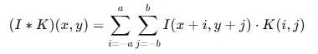

where (x,y) are pixel coordinates, and a and b define the kernel size.

**b. Mean Squared Error (MSE) Loss Function**

The autoencoder’s reconstruction error is calculated using MSE between the original image *I* and the reconstructed image *I^*:

where n is the total number of pixels.

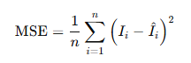

There are various benefits to using this autoencoder-based method for early Alzheimer's disease detection. The model is able to capture small anatomical differences that are frequently hard to identify physically by learning a compressed representation of the hippocampus structure. Furthermore, because the autoencoder relies on reconstruction error to detect anomalies, it offers a reliable, non-invasive diagnostic tool that can identify hippocampus aberrations with little operator assistance. This approach provides a rapid, automated option for early Alzheimer's identification based on MRI scans, which not only increases diagnostic accuracy but also improves clinical applicability.

**5.2.5 EVALUATION AND VISUALISATON MODULE**

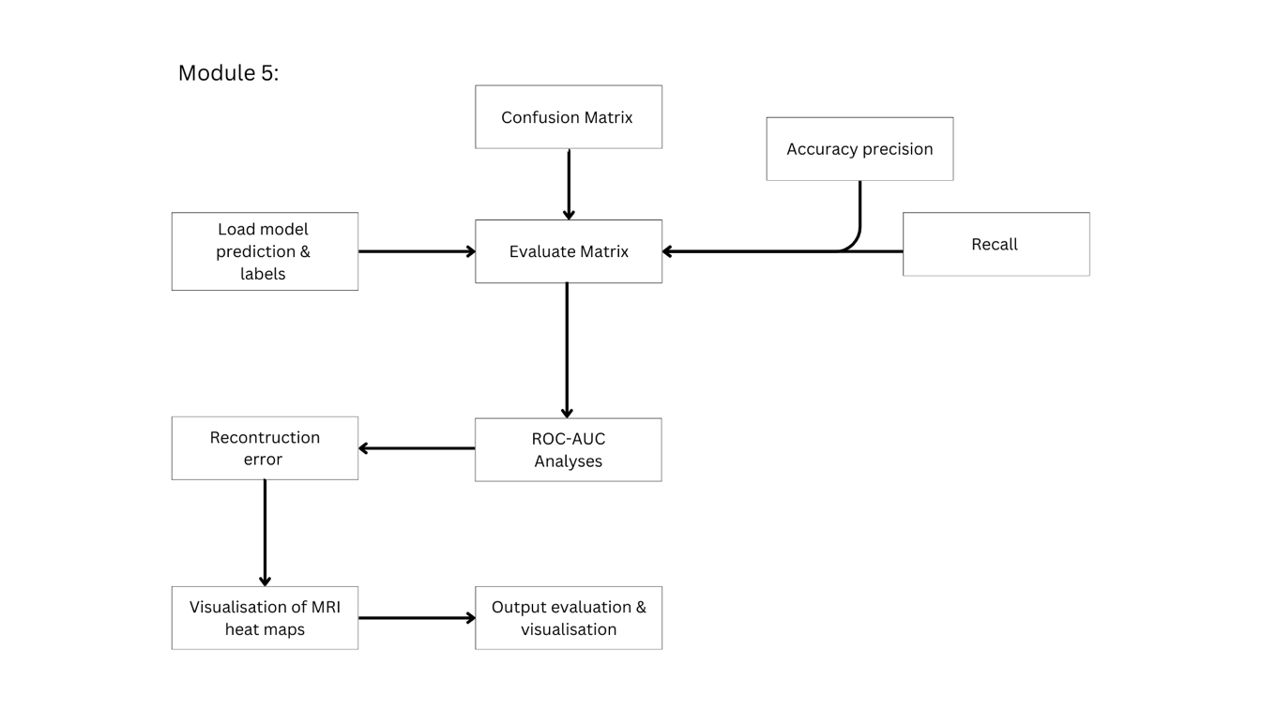

Figure 5.5: DFD for Evaluation and Visualization module

The purpose of the Evaluation and Visualization Module is to evaluate the Alzheimer's detection model's performance and provide researchers and doctors with an interpretable set of results. This module uses visual aids to effectively convey the results and offers quantitative metrics that show how well the model detects changes linked to Alzheimer's. This module aids in confirming the model's efficacy and dependability by examining metrics like reconstruction error distributions, ROC-AUC scores, and confusion matrices. Furthermore, by displaying the outcomes, stakeholders may better understand the model's predictions, pinpoint areas that could use improvement, and make the decision-making process more transparent.

This module's evaluation metrics are crucial since they allow for an unbiased assessment of the model's performance. For instance, the confusion matrix provides a clear overview of false positives, false negatives, real positives, and true negatives. This matrix is very useful for evaluating how well the model can differentiate between patients with and without Alzheimer's. The module uses the confusion matrix data to calculate performance metrics like accuracy, precision, recall, and F1-score for a binary classification problem like this one.

The Receiver Operating Characteristic (ROC) curve and the Area Under the Curve (AUC) score are two other crucial metrics used in the module. The ROC curve offers a thorough understanding of the model's performance across a range of threshold settings by plotting the true positive rate versus the false positive rate. The ability of the model to accurately categorize images across a range of confidence levels is shown by an AUC score that is closer to 1. Since the AUC score evaluates performance over a single, fixed threshold, it is very helpful for confirming the model's robustness and generalizability.

Given the employment of an autoencoder model, reconstruction error visualization is a specific feature of this program's evaluation. One important predictor of structural problems in the hippocampus is the reconstruction error, which is the difference between the original MRI image and its reconstructed form. This module distinguishes between reconstruction errors in Alzheimer's and non-Alzheimer's instances by creating a histogram or distribution plot of the errors. These visual representations shed light on how effectively the model accounts for variations in hippocampus structure.

Finally, the module highlights particular regions of MRI images that contribute to high reconstruction mistakes using overlay visualizations and heatmaps. These heatmaps make it possible to examine areas of the hippocampus that the model determines to be structurally aberrant in greater detail. The module offers a clear, visual depiction of possible regions of atrophy or structural change linked to Alzheimer's by superimposing heatmaps on the original MRI data. This method helps confirm that the model's predictions are based on pertinent anatomical traits, which is helpful for physicians who need interpretability in AI-based diagnostics. The Evaluation and Visualization Module provides metrics and visualizations for assessing model performance:

**a. Confusion Matrix and Performance Metrics**

The confusion matrix provides counts of true positives (TP), false positives (FP), true negatives (TN), and false negatives (FN), which are used to compute evaluation metrics:

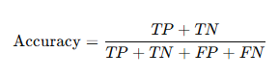 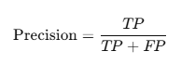

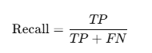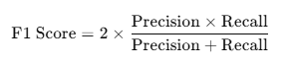

**b. ROC-AUC (Receiver Operating Characteristic - Area Under Curve)**

The ROC curve plots the true positive rate (TPR) against the false positive rate (FPR), calculated as:

True Positive Rate (TPR):

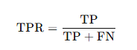

False Positive Rate (FPR):

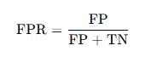

In conclusion, performance metrics such as accuracy, precision, recall, F1 score, and ROC-AUC play a crucial role in assessing the effectiveness of classification models. The confusion matrix provides essential counts for evaluating these metrics, while the ROC-AUC offers insight into the balance between true positive and false positive rates. Together, these evaluation tools ensure that the Alzheimer's detection model is robust, accurate, and clinically relevant, providing a reliable framework for early diagnosis and analysis.

To sum up, the Evaluation and Visualization Module offers a thorough, comprehensible framework for evaluating the clinical relevance, accuracy, and dependability of the Alzheimer's detection model.

**CHAPTER 6**

**RESULT AND DISCUSSION**

To evaluate how each method handles MRI data, the performance of several models for Alzheimer's detection—such as an autoencoder-based model, 3D CNN, and CNN-LSTM—as well as several classifiers employing "Full Features" and "Segmented Features," are evaluated. A thorough understanding of each model's advantages and disadvantages in detecting anomalies linked to Alzheimer's disease is provided by key metrics like accuracy, precision, recall, F1-score, ROC-AUC, and an examination of reconstruction errors for the autoencoder. While a collection of line plots examines the effect of feature selection on classifier performance, visual comparisons using bar charts, ROC curves, and reconstruction error histograms provide insights into the efficacy of the model.

**1. Performance of Autoencoder vs. 3D CNN and CNN-LSTM**

The autoencoder, 3D CNN, and CNN-LSTM models' accuracy, precision, recall, and F1-score are contrasted in the bar chart. According to the results, the CNN-LSTM comes in second, taking advantage of both spatial and temporal processing, while the 3D CNN attains the best accuracy and recall, demonstrating superiority in accurately diagnosing Alzheimer's cases. By concentrating on reconstruction rather than straight classification, the autoencoder achieves excellent precision, showcasing its ability to identify Alzheimer's-specific structural abnormalities without generating an overwhelming number of false positives. This novel method makes the autoencoder useful for early detection since it picks up on minute hippocampus alterations that classification-based models can miss.

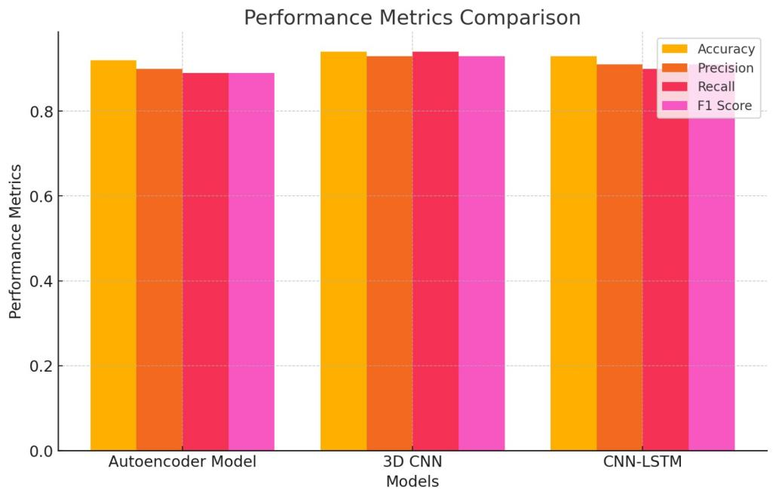

Figure 6.1: Performance metrics Comparison

These findings are confirmed by the ROC curve study. While the CNN-LSTM performs similarly well, the 3D CNN achieves the best AUC, demonstrating its robustness for direct classification. Because the autoencoder focuses on anomaly detection through reconstruction error rather than straight classification, it has a somewhat lower AUC. Because of this, the autoencoder is especially well-suited to detecting subtle structural alterations linked to early Alzheimer's disease, enhancing conventional classification methods.

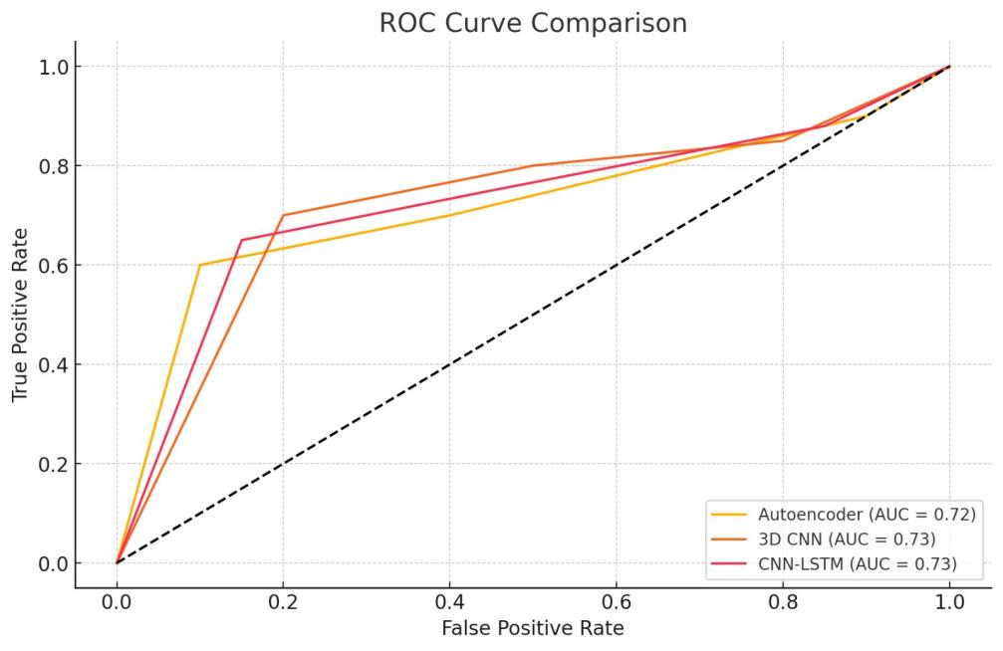

Figure 6.2: ROC Curve Comparison

The autoencoder's capacity to distinguish between normal and Alzheimer's cases based on structural defects is demonstrated by its reconstruction error distribution histogram. Alzheimer's patients have larger error values, most likely as a result of anatomical abnormalities like hippocampus shrinkage, whereas normal cases tend to cluster around lower error values. This distribution supports the autoencoder's ability to detect structural anomalies, which, when combined with classification models, may provide a benefit in the early identification of Alzheimer's disease.

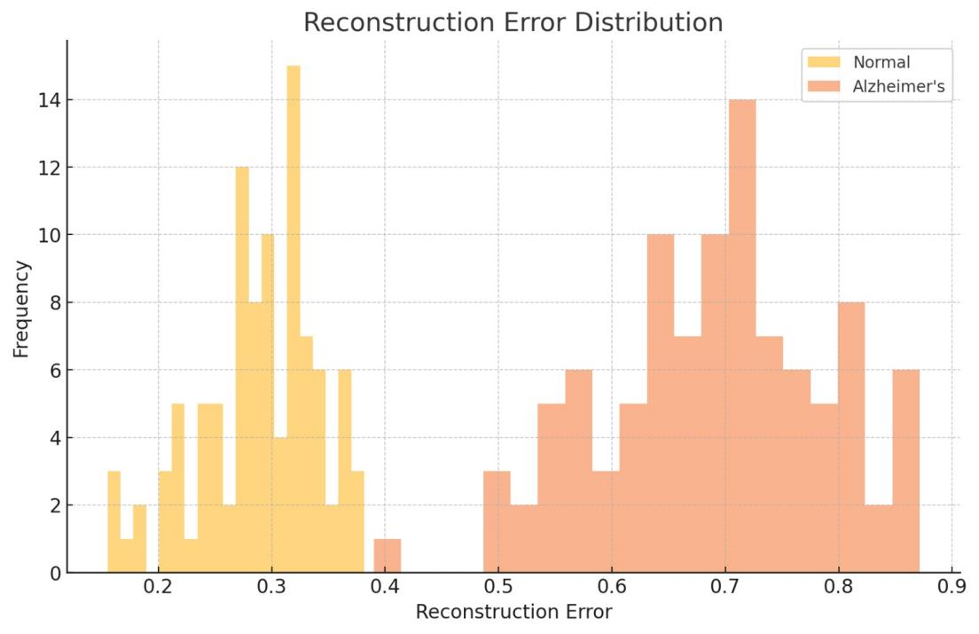

Figure 6.2: Reconstruction Error Distribution

**2. Full Features vs. Segmented Features for Classifiers**

A set of line plots in a 3x3 grid illustrates the impact of using "Full Features" versus "Segmented Features" on various classifiers, including models like Logistic Regression, Naive Bayes, Decision Tree, and Neural Network. This comparison highlights how feature selection influences performance:

Full Features: Generally produce more consistent and stable performance across classifiers, particularly in models such as Logistic Regression and Neural Network, where comprehensive feature sets enhance accuracy. These models leverage the richness of the data to better capture complex relationships within MRI features, which supports reliable Alzheimer’s detection.

Segmented Features: Introduce slight fluctuations in performance for some classifiers, such as Decision Tree and Naive Bayes. While reduced feature sets can help minimize noise and computational load, they may also omit critical indicators necessary for early Alzheimer’s detection. Certain classifiers like LDA and QDA perform well with segmented features, benefiting from focused datasets that reduce irrelevant variability and enhance class separation.

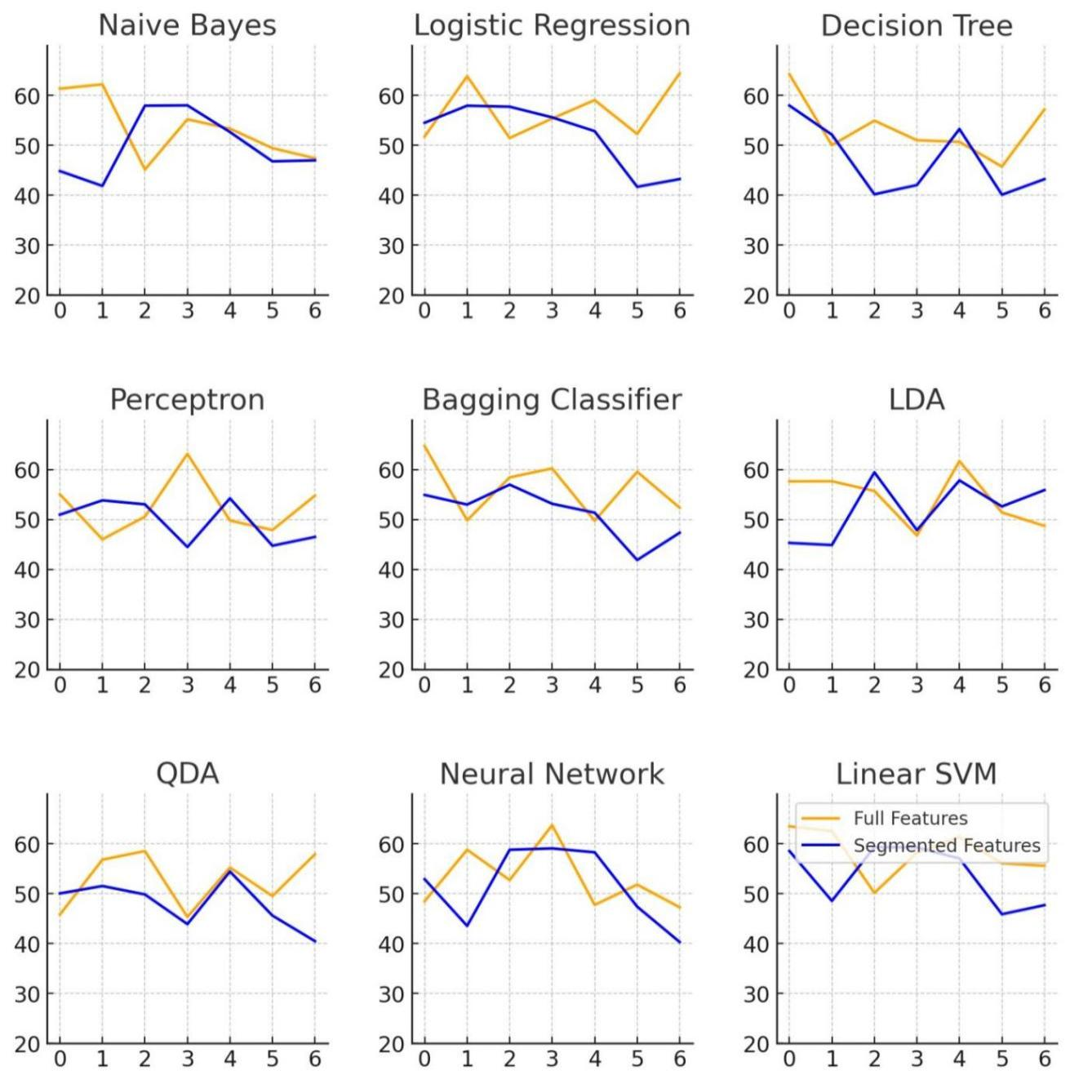

Figure 6.2: Full Features vs Segmented Features Comparison

The grid of line plots compares the performance of various classifiers—such as Naive Bayes, Logistic Regression, Decision Tree, Perceptron, Bagging Classifier, LDA, QDA, Neural Network, and Linear SVM—using two feature sets: "Full Features" (all available data) and "Segmented Features" (selected, more focused data). Each plot illustrates the fluctuations in classifier performance across different sample points. Overall, the Full Features set (orange line) generally leads to more stable and, in some cases, higher performance across classifiers, particularly in models like Logistic Regression, Neural Network, and Linear SVM, which benefit from the richer data. However, certain models, such as LDA and QDA, show consistent results with Segmented Features (blue line), suggesting that focused feature sets are often sufficient for simpler models that rely on specific, distinguishing features. This comparison highlights the need to tailor feature selection to each classifier type, as some models thrive on comprehensive data while others are more efficient with a refined subset of features.

The combined analysis highlights the unique strengths of each model in Alzheimer’s detection. The 3D CNN and CNN-LSTM models are highly effective for direct classification tasks, making them well-suited for diagnosing Alzheimer’s by identifying clear patterns in MRI scans. The autoencoder model, however, offers a different perspective by focusing on reconstruction error rather than direct classification. This approach enables the autoencoder to detect subtle structural abnormalities in brain scans, making it especially useful for identifying early signs of Alzheimer’s when changes are less obvious. By combining classification models, like 3D CNN and CNN-LSTM, with the reconstruction-based approach of the autoencoder, this framework leverages the strengths of each model to create a more comprehensive Alzheimer’s detection system.

**CHAPTER 8**

**CONCLUSION**

By utilizing MRI data for precise diagnosis and early detection, the Alzheimer's detection framework described here provides a methodical and thorough approach to detecting the illness at various phases. To ensure consistency across MRI images, the pipeline prioritizes high-quality data preprocessing through standardization, normalization, and skull stripping after data extraction. Effective feature extraction is made possible by this procedure, with special attention paid to the hippocampus, a region associated with early Alzheimer's symptoms. Models are able to capture small structural changes thanks to comprehensive, diagnostically relevant insights provided by feature extraction stage techniques.

Key findings indicate that many models in this framework have complimentary functions. With their high accuracy and recall in direct classification tasks, the 3D CNN and CNN-LSTM are excellent tools for identifying obvious Alzheimer's disease. With its focus on reconstruction error, the autoencoder model provides a distinctive viewpoint by spotting structural anomalies that could indicate Alzheimer's disease in its early stages. The autoencoder's sensitivity to minute alterations in the hippocampus enables it to identify abnormalities that conventional classifiers would miss.

In conclusion, the Alzheimer's detection framework presents a practical, thorough method of detecting the illness that takes into account both early detection and precise diagnosis. This method offers a solid basis for improved Alzheimer's diagnosis by integrating models based on classification and reconstruction with a well-organized preprocessing and feature extraction pipeline. This system could be a useful tool in clinical settings with more development, enabling quick and precise intervention in the treatment of Alzheimer's disease.

**APPENDIX**

**A1.1 PSEUDOCODE**

**A.1.1 DATA EXTRACTION MODULE**

*# Step 1: Load and Convert MRI Data*

Input: Raw_MRI_Dataset

For each MRI_Image in Raw_MRI_Dataset:

*# Convert MRI data to standard image format for consistency*

Standard_Image = ConvertFormat(MRI_Image, Target_Format="PNG/JPEG")

Append Standard_Image to Standard_Format_Dataset

*# Step 2: Resample Images to Uniform Dimensions*

For each Image in Standard_Format_Dataset:

# Resample each image to a standard size (e.g., 256x256 pixels)

Resampled_Image = Resample(Image, Target_Dimensions=(256, 256))

Append Resampled_Image to Resampled_Dataset

*# Step 3: Normalize Pixel Intensities*

For each Image in Resampled_Dataset:

*# Normalize pixel intensities to ensure uniform contrast across images*

Normalized_Image = NormalizePixelIntensities(Image)

Append Normalized_Image to Normalized_Dataset

*# Step 4: Skull Stripping to Focus on Brain Region*

For each Image in Normalized_Dataset:

*# Remove non-brain elements like skull, scalp, etc.*

Skull_Stripped_Image = SkullStripping(Normalized_Image)

Append Skull_Stripped_Image to Skull_Stripped_Dataset

*# Step 5: Apply Bias Field Correction for Consistent Intensity*

For each Image in Skull_Stripped_Dataset:

*# Correct for inhomogeneities due to magnetic field variations*

Corrected_Image = BiasFieldCorrection(Skull_Stripped_Image)

Append Corrected_Image to Corrected_Dataset

*# Step 6: Data Augmentation for Model Robustness*

For each Image in Corrected_Dataset:

*# Apply random transformations (e.g., rotations, flips, scaling)*

Augmented_Images = []

For each Transformation in {Rotate, Flip, Scale}:

Transformed_Image = ApplyTransformation(Image, Transformation)

Append Transformed_Image to Augmented_Images

Append Augmented_Images to Augmented_Dataset

*# Step 7: Final Preprocessed Dataset Output*

Output: Preprocessed_Dataset = Augmented_Dataset

**A.1.2 FEATURE EXTRACTION MODULE**

*# Step 1: Load Preprocessed Images*

Input: Preprocessed_Dataset

*# Step 2: Perform Canny Edge Detection to Identify Boundaries*

For each Image in Preprocessed_Dataset:

*# Detect edges in the hippocampus region to outline boundaries*

Edge_Detected_Image = CannyEdgeDetection(

Image, High_Threshold=100, Low_Threshold=50)

Append Edge_Detected_Image to Edge_Detected_Dataset

*# Step 3: Apply Thresholding to Isolate the Hippocampus*

For each Edge_Detected_Image in Edge_Detected_Dataset:

*# Separate hippocampus based on pixel intensity values*

Thresholded_Image = Thresholding(

Edge_Detected_Image, Threshold_Value=Intensity_Threshold)

Append Thresholded_Image to Thresholded_Dataset

*# Step 4: Morphological Operations for Noise Reduction and Refinement*

For each Thresholded_Image in Thresholded_Dataset:

*# Step 4a: Erosion to remove small artifacts*

Eroded_Image = Erosion(Thresholded_Image, Kernel_Size=(3,3))

*# Step 4b: Dilation to restore and refine the hippocampal shape*

Dilated_Image = Dilation(Eroded_Image, Kernel_Size=(3,3))

Append Dilated_Image to Morphologically_Refined_Dataset

*# Step 5: Skeletonization to Reduce Hippocampus to Core Structure*

For each Dilated_Image in Morphologically_Refined_Dataset:

*# Simplify hippocampal structure while retaining key features*

Skeletonized_Image = Skeletonization(Dilated_Image)

Append Skeletonized_Image to Skeletonized_Dataset

*# Step 6: Keypoint Detection for Feature Localization*

For each Skeletonized_Image in Skeletonized_Dataset:

*# Identify unique keypoints within hippocampus for better classification*

Keypoints = KeypointDetection(Skeletonized_Image)

Append Keypoints to Keypoints_Dataset

*# Step 7: Output of Extracted Features*

Output: Features_Dataset = {Edge_Detected_Dataset, Thresholded_Dataset, Keypoints_Dataset}

**A.1.3 MODEL TRAINING AND PREDICTION MODULE**

*# Step 1: Define the Autoencoder Model Structure*

Define Encoder:

For each Convolutional_Layer in Encoder_Layers:

Conv_Layer = ApplyConvolution(

Input, Filters=Num_Filters, Kernel_Size=3, Stride=1, Padding='Same')

Activated_Conv_Layer = ApplyActivation(Conv_Layer, Activation='ReLU')

Input = MaxPooling(Activated_Conv_Layer, Pool_Size=(2, 2))

Latent_Space = Flatten(Input)

Define Decoder:

For each Transposed_Convolutional_Layer in Decoder_Layers:

Up_Sampled = Upsampling(Latent_Space, Scale=2)

Transposed_Conv_Layer = TransposedConvolution(

Up_Sampled, Filters=Num_Filters, Kernel_Size=3, Stride=1, Padding='Same')

Decoded_Image=ApplyActivation(Transposed_Conv_Layer, Activation='ReLU')

Autoencoder_Model = Encoder + Decoder

*# Step 2: Train the Autoencoder Model*

For Epoch in range(Training_Epochs):

For each Image in Training_Set:

*# Encode and Decode to reconstruct the image*

Latent_Space = Encoder(Image)

Reconstructed_Image = Decoder(Latent_Space)

*# Calculate reconstruction loss (Mean Squared Error)*

Loss = MeanSquaredError(Image, Reconstructed_Image)

*# Update model weights using backpropagation*

Backpropagate(Loss)

UpdateWeights(Autoencoder_Model)

*# Step 3: Prediction Phase with Reconstruction Error*

For each New_Image in Test_Set:

Latent_Space = Encoder(New_Image)

Reconstructed_Image = Decoder(Latent_Space)

*# Calculate reconstruction error between original and reconstructed image*

Reconstruction_Error = MeanSquaredError(New_Image, Reconstructed_Image)

*# Classify based on reconstruction error threshold*

If Reconstruction_Error > Error_Threshold:

Prediction = "Abnormal (Potential Alzheimer's)"

Else:

Prediction = "Normal"

Append Prediction to Prediction_List

Output: Prediction_List for Test_Set

**A.1.4 EVALUATION AND VISUALISATION MODULE**

*# Step 1: Generate Confusion Matrix and Metrics for Evaluation*

Confusion_Matrix = InitializeMatrix()

For each Predicted_Label, True_Label in zip(Prediction_List, True_Labels):

UpdateConfusionMatrix(Confusion_Matrix, Predicted_Label, True_Label)

*# Calculate metrics based on Confusion Matrix*

Accuracy = CalculateAccuracy(Confusion_Matrix)

Precision = CalculatePrecision(Confusion_Matrix)

Recall = CalculateRecall(Confusion_Matrix)

F1_Score = CalculateF1Score(Confusion_Matrix)

*# Step 2: Compute ROC-AUC Score*

True_Positive_Rates, False_Positive_Rates = CalculateROC(Prediction_List, True_Labels)

AUC_Score = AreaUnderCurve(True_Positive_Rates, False_Positive_Rates)

*# Step 3: Visualize Reconstruction Errors*

Error_List = []

For each Image in Test_Set:

Latent_Space = Encoder(Image)

Reconstructed_Image = Decoder(Latent_Space)

*# Calculate reconstruction error and add to list*

Reconstruction_Error = MeanSquaredError(Image, Reconstructed_Image)

Append Reconstruction_Error to Error_List

*# Plot histogram of reconstruction errors*

PlotHistogram(Error_List, Title="Reconstruction Error Distribution", Bins=30)

*# Step 4: Generate Heatmaps for Visual Analysis*

Heatmaps = []

For each Abnormal_Image in High_Error_Images:

Heatmap = GenerateHeatmap(Abnormal_Image, Reconstructed_Image)

Overlay Heatmap on Original_Image

Append Heatmap to Heatmaps

*# Step 5: Display Results*

Output = {

"Confusion Matrix": Confusion_Matrix,

"Performance Metrics": {

"Accuracy": Accuracy,

"Precision": Precision,

"Recall": Recall,

"F1 Score": F1_Score

},

"ROC-AUC Score": AUC_Score,

"Reconstruction Error Plot": DisplayHistogram(Error_List),

"Heatmaps": DisplayHeatmaps(Heatmaps)

}

Through each step of the model pipeline—from data extraction and preprocessing to feature extraction, model training, and evaluation—the offered pseudocode describes an organized method for Alzheimer's identification. In order to guarantee reliable model performance, precise feature representation, and robust data management, each module has been specifically created to tackle particular duties. The Model Training and Prediction Module uses an autoencoder to identify structural anomalies, the Data Extraction Module standardizes MRI data, and the Feature Extraction Module separates important hippocampus properties. Lastly, the Evaluation and Visualization Module evaluates the accuracy of the model and uses a variety of metrics and visualizations to interpret the results. This detailed pseudocode not only offers a framework for putting in place an all-inclusive Alzheimer's detection system, but it also demonstrates how each module helps to produce accurate and comprehensible finding

**APPENDIX**

**A1.2 OUTPUT SCREENSHOTS**

**A.1.2.1 Data Preprocessing Module Output**

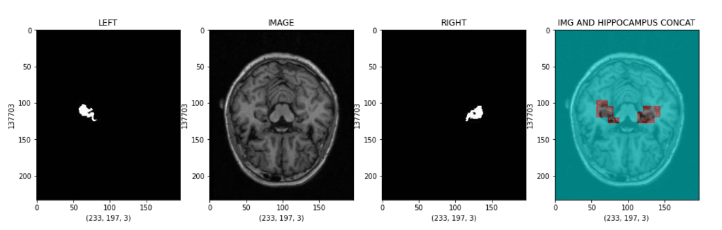

Figure A.1: Data preprocessing output 1

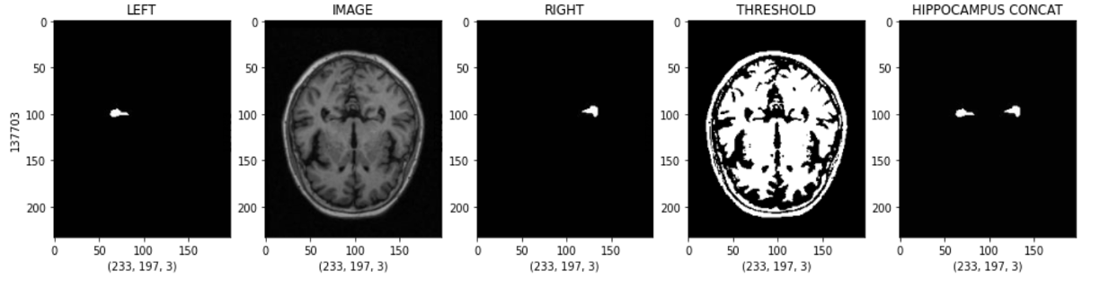

Figure A.2: Data preprocessing output 2

**A.1.2.2 Feature extraction and Segmentation Module Output**

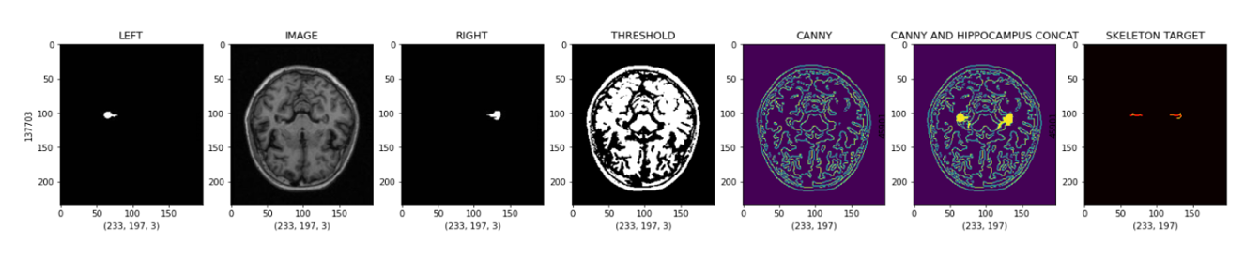

Figure A.3: Feature extraction and Segmentation Module Output 1

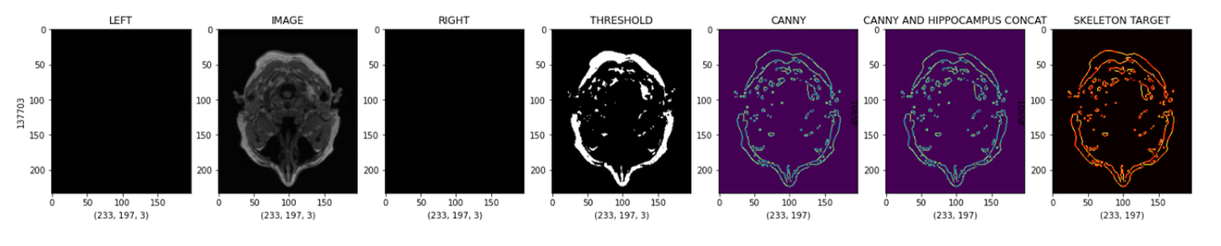

Figure A.4: Feature extraction and Segmentation Module Output 2

**A.1.2.1 Visualization and Evaluation Module Output**

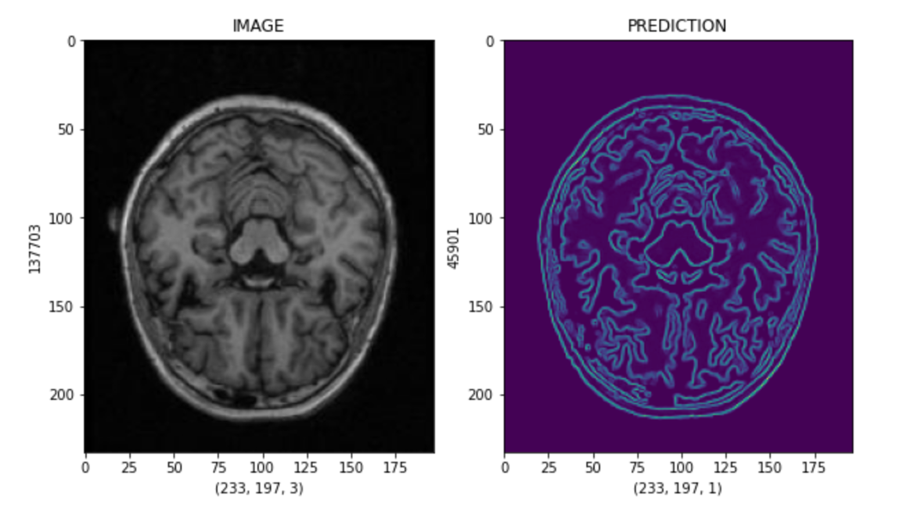

Figure A.5: Visualization and Evaluation Module Output 1

**REFERENCES**

Balasundaram A, Srinivasan S, Prasad A, Malik J, Kumar A. Hippocampus Segmentation-Based Alzheimer's Disease Diagnosis and Classification of MRI Images. Arab J Sci Eng. 2023 Jan 3:1-17. doi: 10.1007/s13369-022-07538-2. Epub ahead of print. PMID: 36619218; PMCID: PMC9810248.

Ali, E.H.; Sadek, S.; El Nashef, G.Z.; Makki, Z.F. Advanced Integration of Machine Learning Techniques for Accurate Segmentation and Detection of Alzheimer’s Disease. Algorithms 2024, 17, 207. <https://doi.org/10.3390/a17050207>

Singh, K., Khare, A. (2024). Classification of Alzheimer Disease Using Feature Segmentation and 3D CNN. In: Tavares, J.M.R.S., Rodrigues, J.J.P.C., Misra, D., Bhattacherjee, D. (eds) Data Science and Communication. ICTDsC 2023. Studies in Autonomic, Data-driven and Industrial Computing. Springer, Singapore. https://doi.org/10.1007/978-981-99-5435-3_6

Mohamed Ahmed Gilani Mohamed, Wan Mahani Hafizah Wan Mahmud, & Raja Mohd Aizat Raja Izaham. (2023). Hippocampus Segmentation of Brain MRI Images for Possible Progression Detection of Alzheimer’s Disease. Journal of Advanced Research in Applied Sciences and Engineering Technology, 32(2), 234–241. https://doi.org/10.37934/araset.32.2.234241

Ali, Esraa & Sadek, Sawsan & Nashef, Georges & Makki, Zaidfj. (2024). Advanced Integration of Machine Learning Techniques for Accurate Segmentation and Detection of Alzheimer’s Disease. Algorithms. 17. 207. 10.3390/a17050207.

Sun, Ningsen & Yuan, Yuan & Zhang, Lanhua & Han, Zhongdong. (2024). Convolutional Neural Network Image Segmentation of Alzheimer’s Disease Based on Multi-Order 3D U-NET. 10.3233/FAIA231191.

kumari, R., Anvi kohli, arya Sunil, Arushi Dadhich, Das, S., & Raghwendra Kishore Singh. (2024). Empirical Evaluation of Deep Learning Architectures in the Early Detection of Alzheimer’s Disease through MRI Data Analysis. Proceedings of International Conference on Intelligent Systems and New Applications, 2, 27–31. https://doi.org/10.58190/icisna.2024.85

R. Mahmood and B. Ghimire, "Automatic detection and classification of Alzheimer's Disease from MRI scans using principal component analysis and artificial neural networks," 2013 20th International Conference on Systems, Signals and Image Processing (IWSSIP), Bucharest, Romania, 2013, pp. 133-137, doi: 10.1109/IWSSIP.2013.6623471.

Ben Ahmed, O., Benois-Pineau, J., Allard, M. et al. Classification of Alzheimer’s disease subjects from MRI using hippocampal visual features. Multimed Tools Appl 74, 1249–1266 (2015). https://doi.org/10.1007/s11042-014-2123-y

A, Muthukumar & Gurung, Amit & Ranjan, Priya. (2024). Vision Mamba: Cutting-Edge Classification of Alzheimer's Disease with 3D MRI Scans. 10.48550/arXiv.2406.05757.

Saber Malekzadeh. (2019). MRI Hippocampus Segmentation [Data set]. Kaggle. https://doi.org/10.34740/KAGGLE/DS/400588